**4. ReactJS-HOL**

1. Create React App

|  |
| --- |
| npx create-react-app blogapp |

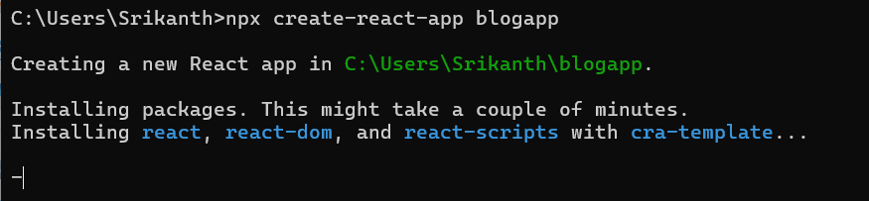

2. Create Post.js in src

|  |
| --- |
| Post.js  import React from 'react';  class Post extends React.Component {    render() {      return (        <div>          <h3>{this.props.title}</h3>          <p>{this.props.body}</p>        </div>      );    }  }  export default Post; |

3 Create Posts.js in src

|  |
| --- |
| Posts.js  import React from 'react';  import Post from './Post';  class Posts extends React.Component {    constructor(props) {      super(props);      this.state = {        posts: []      };    }    loadPosts() {      fetch('https://jsonplaceholder.typicode.com/posts')        .then((res) => res.json())        .then((data) => {          this.setState({ posts: data });        });    }    componentDidMount() {      this.loadPosts();    }    componentDidCatch(error, info) {      alert("An error occurred while loading posts.");    }    render() {      return (        <div>          {this.state.posts.slice(0, 10).map((post) => (            <Post key={post.id} title={post.title} body={post.body} />          ))}        </div>      );    }  }  export default Posts; |

4.Modify App.js

|  |
| --- |
| App.js  import React from 'react';  import './App.css';  import Posts from './Posts';  function App() {    return (      <div className="App">        <h2>Welcome to BlogApp</h2>        <Posts />      </div>    );  }  export default App; |

5. Run App

|  |
| --- |
| npm start |

**OUTPUT:**

